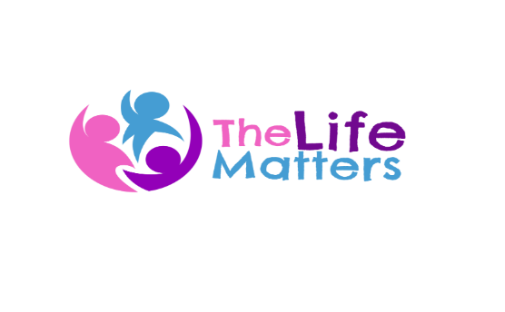
Referral Form

CONFIDENTIAL

Services for Children and Young People provides targeted prevention and early intervention, information, advice, guidance for children aged 08 (Year) to 18 years old. We also work with care leavers, young adults with learning disabilities (LD) and all other vulnerable groups.
If the presenting need(s) of the young person are unlikely to be met through prevention and early intervention, please contact the safeguarding lead on 01634 714088 for advice.

A young person can be referred by downloading and completing this form, and email it to thelifematters@outlook.com

The charity requires that all the boxes are filled in before the application is considered by the trustees

Your referral will be sent to the relevant team, and you will be contacted within a few days to discuss how best we can meet the young person's needs. In the event you are not contacted in a few days please contact us on 07760 464294 or email thelifematters@outlook.com

PART 1
Charity Case No: ** |  | Has Parental consent been given |  | Date  Signature
Case assigned to:**
Account Code: ** |  | Has the child given consent ? |  | Date
Date of referral
**To be allocated by the charity
Young person’s name |  | Preferred first name | Gender | Date of birth
Last name | First name

Home address & Postcode | Telephone number(s): |  | E-mail address
 | Mobile | Home

Is the young person being referred:
Attending a school or college? If yes, please state which. | Being home educated? | Currently not in education, employment or training (NEET)? | Other

Parent/carer name(s) |  | Telephone number | E-mail address
Last name | First name
Does parent have Parental Responsibility? | Yes / No

Young person’s GP surgery
Young person’s GP name
Young person’s Social Workers contact details
Is this a self-referral? | Yes / No
Is the young person aware of this referral? | Yes / No

Referrer Contact Details
Name of person making the referral
Signature
Name and address of referring school/agency / department/ Council/Others

E-mail address
Telephone / mobile number

PART 2 Is the young person accessing support from any other service / agency?
Name of services, practitioner and contact details.

PART 3 Please use the box below to explain why you are making this referral and what you are looking to achieve?

Referral criteria. Please tick ONE primary risk / need / issue from the list below:

☐ Risk of engagement in violence / gangs / crime / anti-social behaviour.

☐ Risk of child sexual exploitation and / or a need for better understanding of appropriate, healthy and safe relationships.

☐ Need for improved emotional and mental wellbeing.

☐ Need for sexual health and relationship information.

☐ Need to understand the risks of smoking, substance and alcohol misuse.

☐ Not in education training or employment. Support to engage / re-engage in education and preparation for training and work.

☐ Lack of resilience, confidence and self-esteem.

☐ Opportunities for involvement in volunteering and social action.

☐ Independent living skills for young people with learning disabilities.

☐ Independent living skills for young parents.

☐ Independent living skills for young people in care and leaving care.

☐ Involvement in local decision-making including planning of services for young people.

☐ Support, information and safe social opportunities for LGBT+ young people.

☐ Excluded or off rolled from school or at risk of becoming so.

Please record any additional risks / needs / issues for the young person in the box below:

Please email the completed form to thelifematters@outlook.com

